**LEBANESE AMERICAN UNIVERSITY**

**USAID – HIGHER EDUCATION SCHOLARSHIP PROGRAM**

**HES - Volunteering Program Verification Form**

This form is to be used to document volunteering hours. If a student volunteers for multiple organizations, a separate form must be used for each organization. **This form must be turned in by the 28th of each month, the latest.**

I certify that the scholar Fatemah Al Slaiby completed a total of 5 hours of service at InnovaThrive.

The hours were completed hours as per the below:

Hours # 5 (date) _4/11 – 8/11_ (initials of supervisor) __A.K.___

Hours # 0 (date) _11/11 – 15/11_ (initials of supervisor) __A.K.___

Hours # 0 date) _18/11 – 22/11 (initials of supervisor) __A.K.___

Hours # 0 date) _25/11 - 29/11 (initials of supervisor) __A.K.___

Brief description of the activities the scholar performed or participated in:

My first task was about academics covering the idea of "Blockchain and Academic Credentials Verification ."" First , I made sure to follow the body of the research indicated in the email. I started by defining the concept of Blockchain by checking a couple of cites that suggested the idea of Blockchain technology . I did some research from different sources to extract the advantages and disadvantages of blockchain ( I cited all the references ) . Moreover , I covered every concept needed, including statistics (all numbers are from studies) . I added some extra points that I thought it might be useful in the "Technological Process" part. Finally , I summarized the last concept needed about "Future Research Directions" in small points that deliver the idea properly without adding unnecessary information which is talking about how the future is going to deal with blockchain and how it might be developed.

Written feedback about the scholar’s performance:

.Fatemah’s thorough research on blockchain in academic credential verification reflects her analytical depth and ability to summarize complex topics effectively. Her well-cited work demonstrates her commitment to academic rigor.

Please rate the overall performance of the scholar at your organization:

|  |  |  |  |
| --- | --- | --- | --- |
|  | Mastery (5) | Proficient (3) | Emerging (1) |
| **Problem solver** | X |  |  |
| **Engaged & Committed** | X |  |  |
| **Open-minded & multicultural** | X |  |  |

Signature

& stamp

__________________________

_

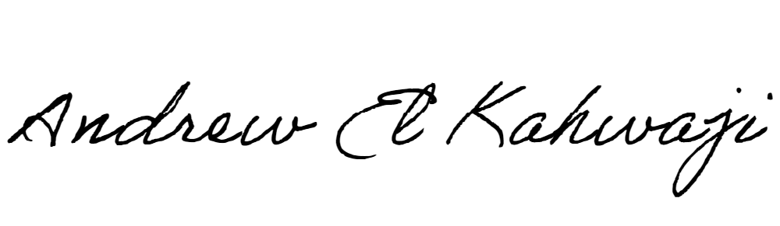

Printed Name _Andrew El Kahwaji_

Date __26/11/2024___

Email __andrew.lifesculptor.coo@gmail.com __

Phone __+961 71 914 378__

**LEBANESE AMERICAN UNIVERSITY**

**USAID – HIGHER EDUCATION SCHOLARSHIP PROGRAM**

